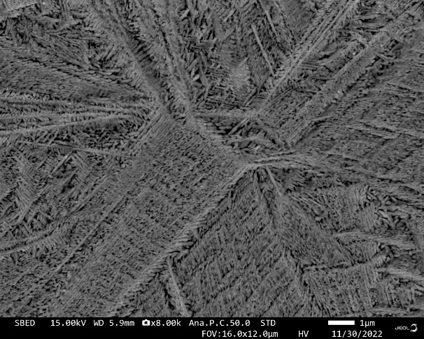
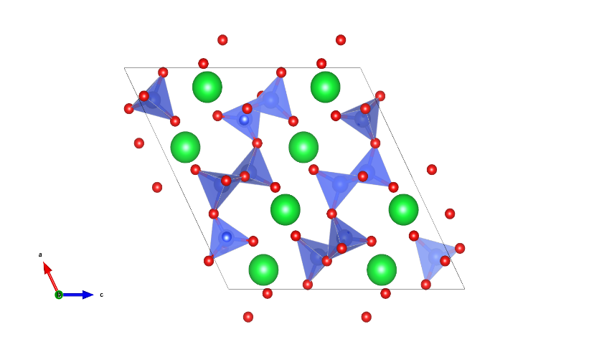
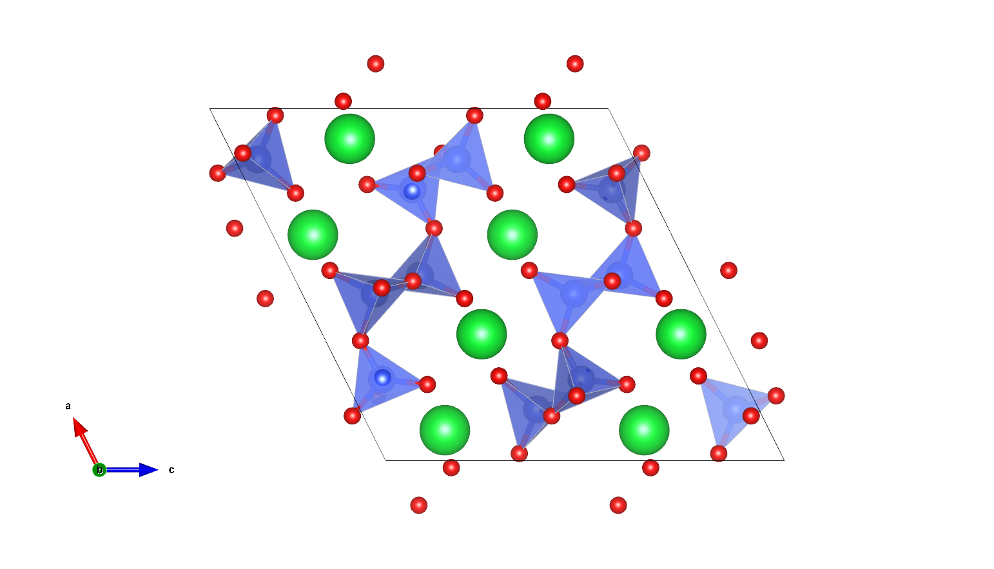
Zwier
Ribbons
Sr1
SiO₄ units
Sr2

Figure 4: SEM image of Sr₂Si₃O₈ synthesised with aluminium.
Figure 1: Unit cell of Sr₂Si₃O₈ showing the Zwier ribbons, strontium atomic positions and the silicon-oxygen tetrahedral units, generated on VESTA.

