Processing of joinning glass on metal with pulsed laser: trade-off between nanoseconde and femtosecond lasers

In Biomedical, ( microfluidics devices per example) Photovoltaic and Microelectronics especially MEMS and 4.0 industries, many devices combine materials of different physical and mechanical properties such as silicon on glass and glass and metal. Welding them is a complex application which still must be improved in terms of speed, preservation of mechanical properties for MEMS and biomedical industries.
Conventional welding methods and continuous laser welding such as anodic fusion, adhesive bonding, and junction by fusing, optical contacting are relatively effective but can be improved in terms of machining speed, thermal and chemical resistance, seam limited length, long term stability, complex pressure tools.
Regarding the welding process, in this work, femtosecond lasers emitting at 1030 and 515 nm are used to weld both glass on glass (sodalime, borosilicate, aluminosilicate) and glass on silicon (mono and polycrystalline) and metal such as Cu, Al and stainless steel. Different ranges of thickness are tested for glasses and metal plates (from 0.7 to 2 mm) and for silicon wafer (from 100 to 300 µm).
Power, pulse duration, frequency, beam diameter focussing and process speed are the key parameters to empower this application. Even with few values for each parameter, the number of experimentations can be tremendous. To reduce with efficiency the time to provide good beads and to optimise the machining speed, numerical modelling is combined with experimental works. Different welding trajectories and strategies configuration (with or without mechanical pressure, parts roughness) are tested.
Different welding strategies led to reach m/s machining speed for glass on silicon/metal welding. Heat treatments reveal that welded samples resist to high thermal shock while the beads are still watertight. In order to propose the most suitable apparel for industries, we are also performing a trade-off between ns and fs IR laser for joining sodocalcic and borosilicate glass on silicon and on metal. We developed mechanics and protocols to weld the dissimilar parts and then define which ways are the best in this trade-off. We performed MEMS and microfluidics like packaging seals by joining silicone and metal on glass and glass on metal.
The mechanisms and protocols developed could be applied to other materials: in particular, for glass/metal sealing where the glass was developed at Cerfav on the basis of a borosilicate type glass, then whose surface condition and parallelism were adapted to the laser welding process developed.

Images and prototypes
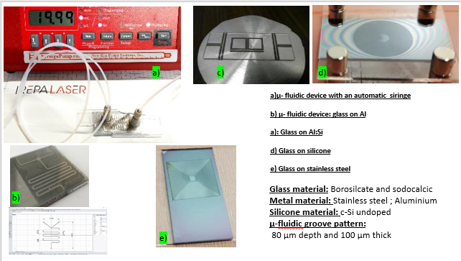
Fig 1 : Iamges of prototypes developed by laser welding of glass on metal and silicone
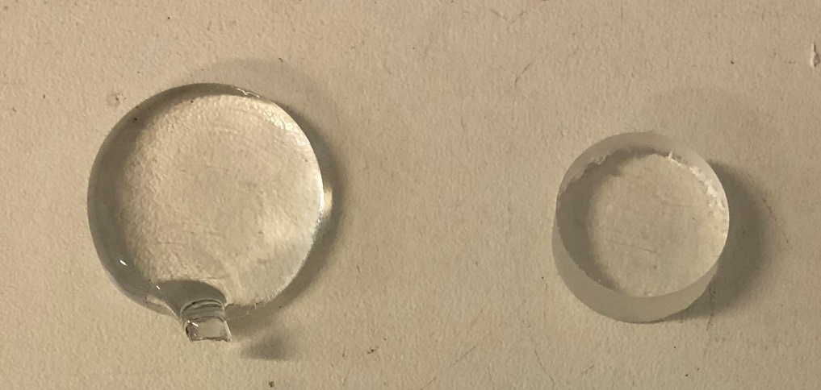
Fig 2 : Glasses especilally designed for the project by CERFAV and used to produce the prototypes of the DIAVEM project sponsored by Région GRAND EST

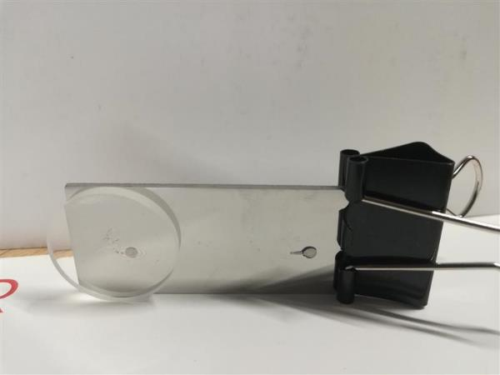
Fig 3 : Sample of CERFAV glass welded on a plate of stainless steel

Names and Affiliations :
Armel BAHOUKA, IREPA LASER ; Parc d’Innovation , 67400 ILLKIRCH, France
Ambre Camus, Théo Desfontaines, Patricia Hee ; Cerfav, Rue de la Liberté, 54112 Vannes-le-Châtel, France

