New approaches for the preparation and characterisation of new glasses
Martin Kilo^{1*}, Andreas Diegeler¹, Ralf Müller², Tina Waurischk², Stefan Reinsch²

¹ Fraunhofer ISC, Außenstelle Bronnbach, Bronnbach 28, 97877 Wertheim/Bronnbach, Germany
² Bundesanstalt für Materialforschung und -prüfung (BAM), Richard-Willstätter-Str. 11, 12489 Berlin, Germany
*martin.kilo@isc.fraunhofer.de

Glass development works traditionally iteratively by melting series of samples, investigating their properties, and then melting more samples with modified composition. Also, for characterisation, one is usually using several separate devices in order to get information about the properties of the new glass. The concept of materials digitalisation which consists of high-throughput techniques needs to get the knowledge about a large range of materials properties. While purely digital approaches might be very fast, and the MD simulation of the density of glass may need only seconds, the acceleration of melting and characterisation techniques is much less dynamic. Together with BAM in Berlin, Fraunhofer ISC is about to continue the development of the glass-screening system [1] and the thermooptical measurement devices [2,3] as two central tools for preparing and characterising glass much faster.

Figure 1. Set-up of the screening device (above) and TOM system (below).

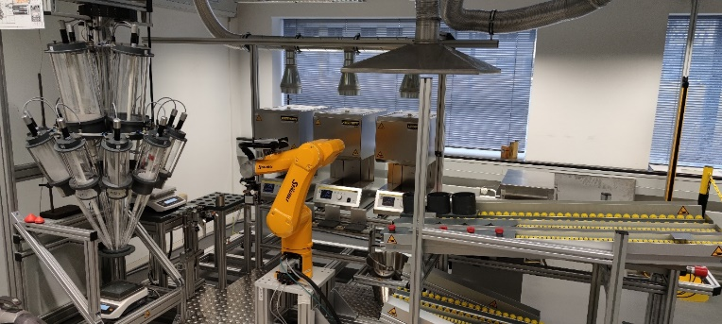
light source
CMOS-camera
PC
optical axis
sample
furnace window

Fraunhofer ISC has developed the Thermo-Optical-Measurement technique in the last years towards an universal tool to investigate various properties of materials at temperatures up to 2000 °C.[3] The heat transfer properties are measured in a large temperature range, also in the odd-described transformation area, as well as thermal expansion and wetting, adhesion, adhesive properties and contact angles of molten glass to different materials.
Viscosity fix points such as glass transition temperature, softening point, working point and melting point are determined using modified tommy set-ups, some of them in combination.
Recent advances may even allow to investigate the crystallization temperatures and the mass-loss during the formation of the melt and the degassing at very high temperatures using mass-spectroscopy.
The thermooptical measurement device allows to determine high temperature materials properties much faster than in stand-alone-devices, in particular if high data-quality is not needed, as is common for large-throughput material development concepts.

Keywords
Thermooptical Methodes; Glass-Screening; Glass-development

References
[1] M: Kilo; J. Alkemper, G. Sextl; in: Multifunktionale Werkstoffe aus Glas für energieeffiziente Gebäudetechnologien : Abschlussbericht FORGLAS, ISBN 978-3-9814164-2-8, Bayreuth, 2012, 117-136.
[2] F. Raether, J. Baber; J. Europ. Ceram. Soc. 27, 2007, 701-705.
[3] A. Diegeler, P. Schulze-Horn, F. Raether Proc. Werkstoffprüfung 27 2007, 79-84.

